Baculovirus based vectors
The Baculovirus Expression Vector System (BEVS) is one of the most powerful and versatile eukaryotic expression systems available. The BEVS is a helper-independent viral system which has been used to express heterologous genes from many different sources, including fungi, plants, bacteria and viruses, in insect cells.
Genome
Baculoviruses (family Baculoviridae) belong to a diverse group of large double stranded DNA viruses that infect many different species of insects as their natural hosts. Baculovirus strains are highly species-specific and are not known to propagate in any non-invertebrate host. The Baculovirus genome is replicated and transcribed in the nuclei of infected host cells where the large Baculovirus DNA (between 80 and 200 kb) is packaged into rod-shaped nucleocapsids. The particular virus that has found widespread application as a vector for expression of heterologous proteins is Autographa californica mononuclear polyhedrosis virus (AcMNPV), for which the complete structure of genome sequence has been determined. AcMNPV has a circular, double-stranded, supercoiled DNA genome of approximately 130 kb, packaged in a rod-shaped nucleocapsid. These nucleocapsids can be extended lengthways, and as a result the virus genome can effectively accommodate large insertions of foreign DNA. Since the size of these nucleocapsids is flexible, recombinant Baculovirus particles can accommodate large amounts of foreign DNA.
Baculovirus expression system
The baculovirus vector most commonly used in industry and research laboratories for recombinant protein production is based on Autographa californica multinuclear polyhedrosis virus (AcMNPV) with Spodoptera frugiperda 9 (Sf9) or 21 (Sf21) insect cells, Trichoplusia ni (T. ni)-derived High Five (Hi-5™) cells, and also whole T. ni insect larvae as suitable expression hosts. One of the genes expressed during the late phase of baculovirus replication is the polyhedrin gene, which has a strong promoter leading to high levels of transcription and massive synthesis of the polyhedrin protein. The baculovirus expression strategy takes advantage of the fact that the polyhedrin protein is dispensable for propagation of the virus in cultured cells and that it can be replaced with a foreign gene of interest. Expression of the foreign gene under control of the polyhedrin promoter results in high levels of protein product.
Because of the large size of the baculovirus genome, unique restriction sites are not available for simple replacement of the polyhedrin gene with the gene of interest. Thus, recombinant viruses are generated by homologous recombination between viral genome and a transfer vector containing the gene of interest flanked by sequences derived from the polyhedrin locus.
Approaches for construction of recombinant AcMNPV
- The gene of interest is first cloned into a transfer vector. Virus DNA and transfer vector are both co-transfected into the host insect cell, and homologous recombination between the flanking sequences commonly occurs for both DNA molecules. This causes the gene of interest to be inserted into the viral genome at the polyhedrin locus, resulting in the production of a recombinant virus genome in which polyhedron gene has been replaced by foreign gene.
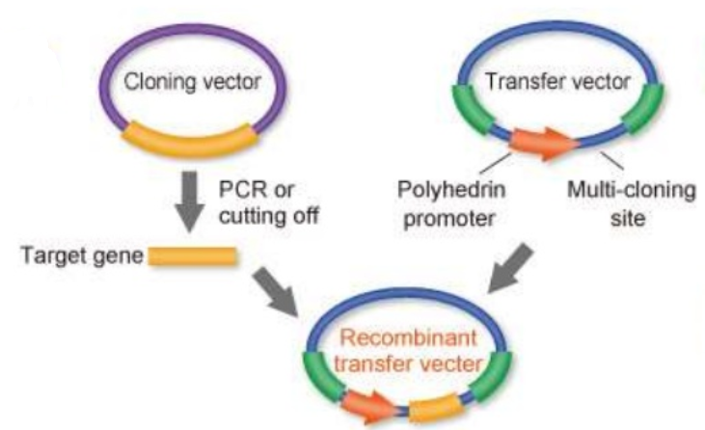
Screening of recombinants is done by using a linearized version of the baculovirus DNA, which lacks a gene essential for replication of the virus, is now commonly used. The essential gene is located on the transfer vector together with the gene of interest and only homologous recombination between the viral DNA and the transfer vector results in viable progeny. This system essentially eliminates the high background of wild-type baculovirus and has accelerated the time required for isolation of recombinants tremendously. Variations of this strategy employ transfer vectors that contain the β-galactosidase gene as a marker, which permits identification of recombinants by formation of blue plaques.
- A different protocol relies on recombination in bacteria rather than insect cells (“Bac-to-Bac” system). The gene of interest is cloned into a donor plasmid, which is transfected into bacteria that carry a baculovirus shuttle vector (“bacmid”) containing the baculovirus genome. Recombination between the donor plasmid and the bacmid, which is facilitated by the presence of Tn7 attachment sites and transposition proteins encoded on a helper plasmid, transposes the gene of interest into the bacmid. Colonies containing recombinant bacmids can be identified by disruption of the lacZα gene.
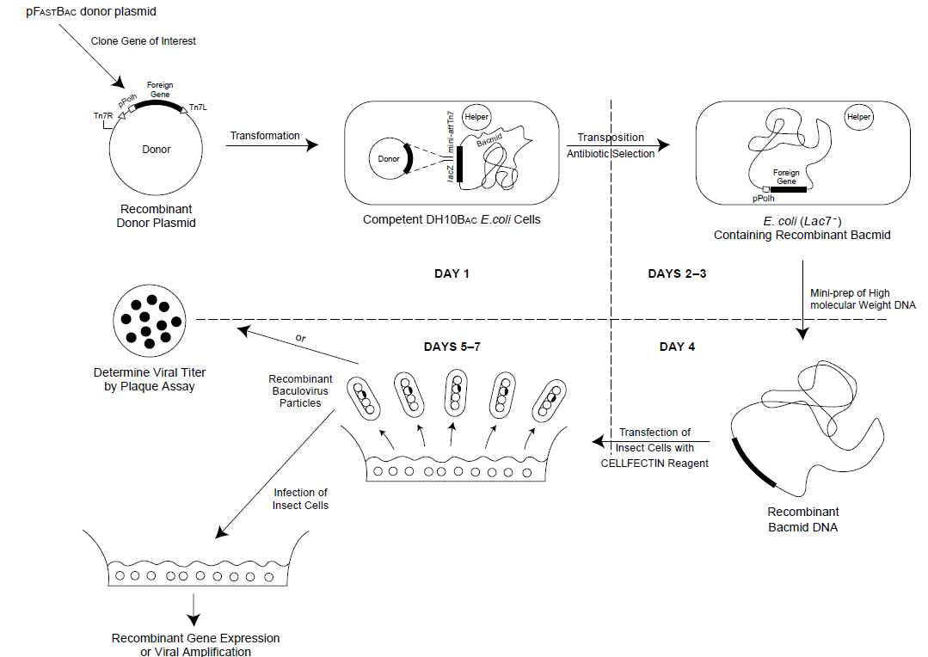
References
- https://www.ncbi.nlm.nih.gov/pmc/articles/PMC4019511/
- https://www.bdbiosciences.com/documents/Baculovirus_vector_system_manual.pdf
- http://tools.thermofisher.com/content/sfs/manuals/bevtest.pdf

